Sites below include codes A-D and allow use of Generic Grade Category Table
Grade Table ID | Site Name, (AJCC ID) | Grade options in table
07 | NET Stomach (29), NET Duodenum & Ampulla Vater (30), NET Jejunum and Ileum (31), NET Appendix (32), NET Colon & Rectum (33), NET Pancreas (34) | AJCC preferred grade system for site, PLUS Generic A-D option
09 | Soft Tissues Head & Neck (40), Soft Tissues Abdomen and Thoracic (excluding Heart, Mediastinum, Pleura) (42), Heart, Mediastinum & Pleura(42), Soft Tissue Other and Kaposi Sarcoma (45), Orbital Sarcoma (70)
10 | Soft Tissues Trunk and Extremities (41), Retroperitoneum (44)
11 | GIST Gastric and Omental (43.1)  GIST Small Intestinal, Esophageal, Colorectal, Mesenteric and Peritoneal (43.2)
12 | Breast DCIS and Paget (48.1); Breast Invasive (48.2)
17 | Prostate (58)
18 | Kidney Parenchyma (60)
20 | Melanoma Iris (67.1), Melanoma Choroid and Ciliary Body (67.2)
21 | Retinoblastoma (68)
24 | Brain, CNS Other, Intracranial Gland (72)
25 | Parathyroid (75)
26 | Adrenal Gland (76)
98 | Cervical Lymph Nodes and Unknown Primary (6); Major Salivary Glands (8); Nasopharynx (9); Oropharynx HPV-Mediated p16+(10); Mucosal Melanoma of the head and neck (14); Thymus (35);Merkel Cell CA (46);Melanoma of the Skin (47); Placenta (56); Testis (59); Melanoma Conjunctiva (66); Thyroid (73); Thyroid-Medullary (74); NET Adrenal Gland (77) | AJCC preferred Grade for sites is the Generic A-D options only.
99 | Pharynx Other, Middle Ear, Sinus Other, Biliary Other, Digestive Other, Trachea, Respiratory Other, Skin Other, Adnexa Uterine Other; Genital Female Other, Genital Maler Other, Urinary Other, Lacrimal Sac, Eye Other, Endocrine Other, Ill-defined Other (NO AJCC ID/Chapter) | No AJCC preferred grading system for sites. Grade for sites is the Generic A-D options only.
Sites NOT listed above do not accommodate use of Generic Grade Categories to code Grade
Quick Reference - Generic Grade Category Table - Which Sites Allow
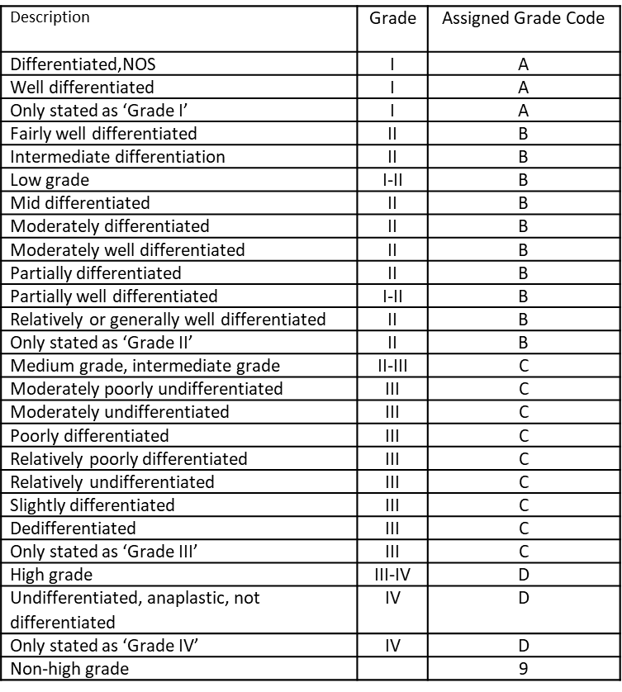
Generic Grade Category Table
If you find this useful, feel free to duplicate or Improve
Donna M. Hansen, CTR
California Cancer Registry
dxhansen@ucdavis.edu

Reminders:
- AJCC preferred Grade always takes priority when documented.

- Refer to Grade Manual, pages 34-35 to review complete instructions on using Generic Grade Category table

